**EXPERIMENT 6**

**DML COMMANDS (COLLEGE SCHEMA)**

**Aim:**

1. Insert 5 instances into the tables created in experiment 6.
2. Display the tables.
3. Add attribute course to student table then insert values.
4. Use update to set course for students.
5. Delete an attribute.
6. Code:

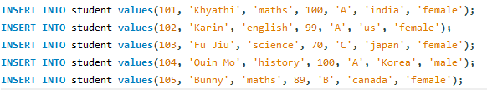

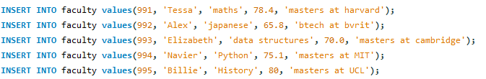

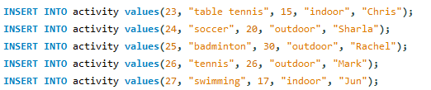

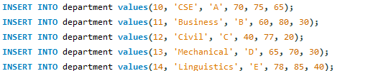

1. Result:

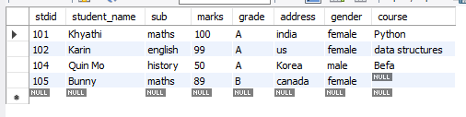

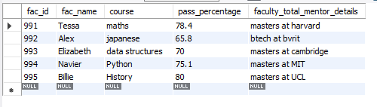

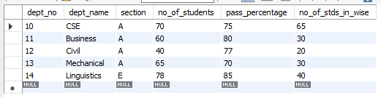

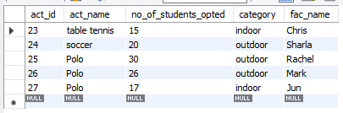

1. Code:



1. Code:

